A Short Introduction to Assessment of Learning Outcomes (or see goals).

Outline

Step 1. Define how your course(s) contributes to the program learning outcomes (PLOs) as formulated for the major.
Step 2. Develop specific learning outcomes for your course within the broad framework of the program learning outcomes.
Step 3: Select a few outcomes to assess each year.
Step 4: Ask yourself what would constitute evidence that students possess the skill level desired.
Step 5: Collect evidence on the proportion of students who meet your learning outcomes and to what standards (e.g., basic level, good, advanced level). Decide whether the class has an adequate level of proficiency. Formulate a short-term plan for filling in student deficiencies within the quarter, or a long-term plan for course changes in the future if needed.
Step 6: Be able to describe your analysis and present sample student work for Program Review and for WASC accreditation.
Step 7: If your course has General Education (GE) certification, you will need to assess student learning outcomes for this area and include the assessment with Program Review documents. See the Program Review documents for a discussion of GE assessment.

A short description of each step with an example is provided below:

Student learning outcomes have been developed at many different levels, starting most broadly at those for all students on the UCD campus and ending with those developed specifically at the course level. A good place for an instructor to start is with the Program Learning Outcomes developed for each major. All programs of study (majors) were required to have these goals in place for the prior WASC review.

Example:
PLB Student Learning Outcomes for the Plant Biology Major:

At the end of their program of study, students will be able to:
- Describe the molecular and structural unity of all life, explain how the diversity of life is generated and perpetuated and exemplify this diversity among and within life's three domains.
- Demonstrate knowledge of how genetics and biochemistry are used to elucidate cell organization and function
- Demonstrate skill in communication of scientific data in standard format.
- Demonstrate scientific quantitative skills, such as the ability to evaluate experimental design, read graphs, and use information from scientific papers.
- Incorporating an evolutionary perspective, describe how plants develop from a single cell to a complex organism.
- Demonstrate an understanding of how plants sense and respond to environmental cues.
- Demonstrate knowledge of the relationship between plant form and function, and apply that knowledge to issues that impact society.
These program learning outcomes (PLOs) provide the framework for the major and your course should fit within them.

Step 1. Define how your course(s) contributes to the program learning outcomes (PLOs) or Student Learning Outcomes (SLOs).

The majors within CBS typically share the first two learning outcomes because these outcomes apply to the required upper and lower division preparatory courses that CBS students take (BIS 2ABC, BIS 101-105 or the NPB variant of this material).

The remaining learning goals apply to the courses specific for the major. Vice-chairs worked with faculty to create a matrix showing how the courses apply to the learning goals. Some departments developed matrices that specify whether each course applies to the learning outcomes at an introductory or an advanced level. In theory, students in the major would demonstrate proficiency in more advanced material as they approach graduation. The term “SLO” refers to “student learning outcomes.”

Example: SLOs for required courses for PLB majors

Course\SLO | 1 | 2 | 3 | 4 | 5 | 6 | 7
PLB102  California Floristics | In part |  |  |  |  |  | In part
PLB105  Developmental Plant Anatomy |  |  |  |  | Limited applicability | Limited applicability | X
PLB108  Systematics and Evolution of angiosperms | X |  |  |  | X |  | X
PLB111  Plant Physiology |  | X | X | X |  | X | X
PLB112  Plant Growth and Development |  | X |  |  |  | X | X
PLB117  Plant Ecology |  |  | X |  |  | X | X
PLB116  Plant Evolution and Morphology | X | In part |  |  | X | In part | X
EVE 140  Paleobotany | X |  |  |  | X |  | X

Students choose between 102 and 108: choose between EVE 140 and PLB 116.

Example: BIS 105 contributes to the second program learning goal:
Demonstrate knowledge of how genetics and biochemistry are used to elucidate cell organization and function

Step 2. Develop specific learning outcomes for your course within the broad framework of the program learning outcomes.

To create these learning goals, consider how your students would demonstrate that they have grasped the material in your class. Bloom’s taxonomy of learning was developed to illustrate levels of thinking from simple recall (describe or explain) to complex analysis (predict or synthesize).

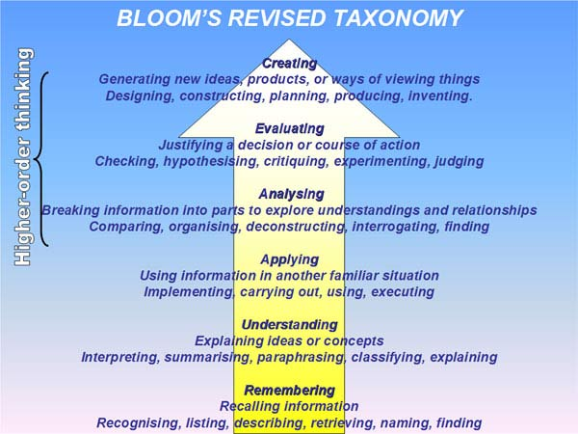
http://www.virtuallibrary.info/blooms-taxonomy.html
or see also http://www.teachthought.com/critical-thinking/blooms-taxonomy/3-dimensional-model-blooms-taxonomy/

The diagram above illustrates a range of thinking skills from low level descriptive skill, such as describe, recall, or explain, to higher level skills such as analysis, prediction, application or synthesis. As you create goals, remember that they are designed to be assessable. For example: “understand population genetics” is not directly assessable whereas “Predict the equilibrium allele frequencies in the absence of evolution” is assessable.
A good set of learning goals for each course should include thinking skills from the range illustrated by Bloom’s taxonomy. A university class should include higher order skills. The chart above contains verbs that have been categorized according to the skill level.

Option: Once the course learning goals are created, you may translate these into learning goals presented to students for each specific lecture. This is helpful for students in that they know the skills expected to result from each lecture. It also makes exam writing easier—one selects one or two learning goals from each lecture and designs questions to test whether the students have met the goal. However, per-lecture learning goals are not required for campus accreditation.

Step 3: Once the course learning outcomes are developed, select a few outcomes to assess each year. Assessment of learning goals is expected to be an iterative process: one decides on goals/outcomes, measures student proficiency for each goal, and then decides whether the class proficiency is adequate. If not, one may re-teach or provide remedial exercises and re-test later in the quarter. If the goal were critical to the mission of the course, re-teaching the material would be worth the redirection of class time. Another option would be to redesign the course to better teach this topic in the next offering. If two or three outcomes are assessed each year, the full set will be assessed over one program review cycle.

Step 4: Ask yourself what would constitute evidence that students possess the skill level desired. Consider your expectations for a range of proficiencies—how will you score the skills range across the class and what level of proficiency is an acceptable baseline for the whole group? Should anyone who passes the class demonstrate some minimal skill level? What fraction of the class should clearly demonstrate proficiency for you to be satisfied with your teaching?

Step 5: Collect evidence on the proportion of students who meet your learning outcomes and to what standards (e.g., basic level, good, advanced level) and decide whether this is adequate. Formulate a short-term plan for filling in student deficiencies within the quarter or a long-term plan for course changes in the future, if need be.

There are many different options for looking for determining proficiency, four of which are listed below:

- Pre-test/post-test. Develop a pre-test for the course that students will take on the first day—the pre-test will indicate the baseline skills the students possess before you teach them and when this test is administered again at the end of the course, the new scores will indicate the learning gain. The trick is to develop a good pretest where student scores will have room to improve and where the skills desired are clearly measured.
Example: This sample pre/post-test from Introductory Biology (BIS2A) usually gives an average of 4 correct out of 14 with the highest score being 10 out of 14.

1. An increase in cellular acetyl-coA is likely to have what effect on enzyme activity? Note: solid arrows represent up-regulation, flat arrows represent down-regulation.
A. decreased activity of enzyme D
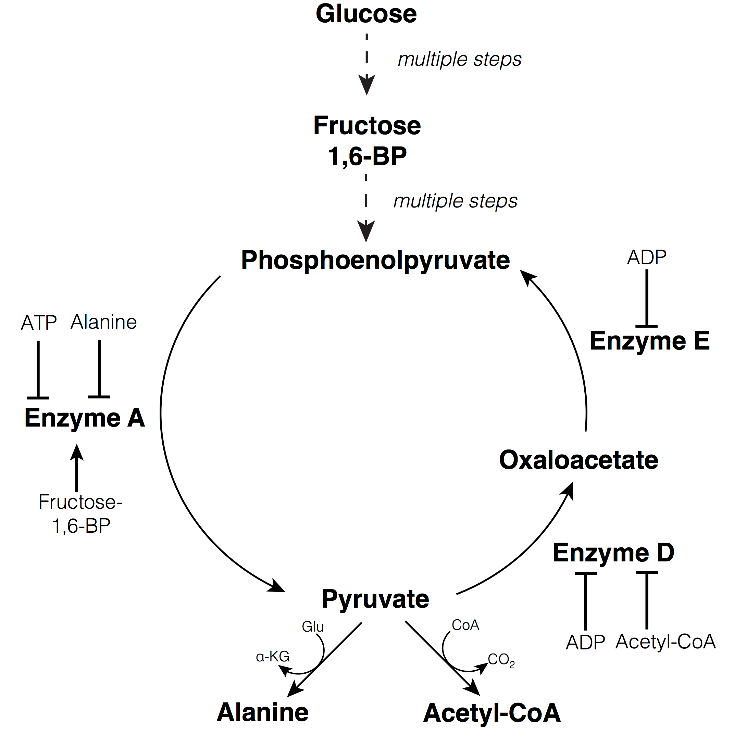
B. increased activity of enzyme D
C. decreased activity of enzyme E
D. increased activity of enzyme E
E. no effect on enzymes D and E

2. Increased cellular production of ATP is likely to have what effect on enzyme activity?
A. decreased activity of enzyme A
B. increased activity of enzyme E
C. decreased activity of enzyme D
D. A and B only
E. A, B and C

3. Cyanide inhibits electron transfer in the respiratory electron transport chain between the ETC protein cytochrome C oxidase and the terminal electron acceptor. Addition of cyanide is likely to lead to ____________ Enzyme A activity and ________ Enzyme E activity.

- increased; increased
- decreased; decreased
- increased; decreased
- decreased; decreased
- no change in; no change in

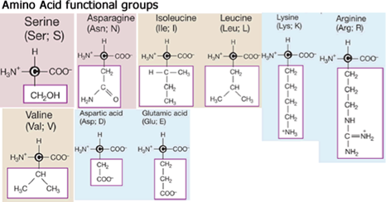
4. Which of the following amino acid side chains can form hydrogen bonds with each other?
A. Arg & Leu
B. Val & Asn
C. Asn & Ser
D. Ser & Val
E. Val & Ile

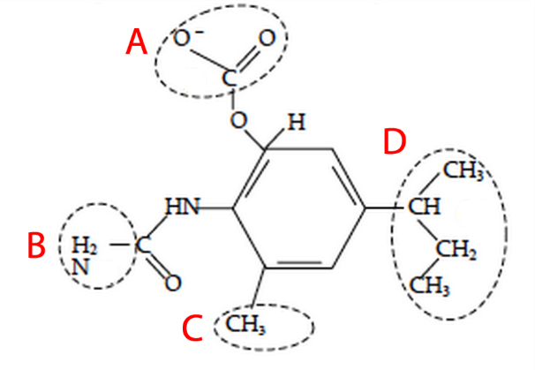
5. Shown to the right is the structure of a possible new antibiotic drug that binds to the E. coli ribosome. It is shown in the protonation form it takes inside a cell. Listed in the table below are the types of interactions each circled region could possibly form with another molecule (ionic bonds, hydrogen bonds, or hydrophobic interactions).

Which row (A, B, C, or D) has a mistake?

Region | Can form ionic bonds | Can form hydrogen bonds | Can form hydrophobic interactions
A | yes | yes | no
B | no | yes | no
C | no | no | yes
D | no | yes | yes

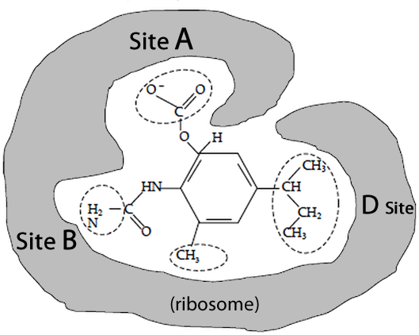
6. (Cont. from previous question) When the drug was tested on two different species of bacteria, it binds to the ribosome of E. coli and species 1, but not species 2. Based on the data below, which specific amino acid or amino acids prevent(s) the ribosome from species 2 from binding the drug?
A. Glu (site A)
B. Ser (site B)
C. Val (site D)
D. Glu & Ser (sites A and B)
E. Ser & Val (sites B and D)

Ribosomes from: | Site A  (amino acid) | Site B  (amino acid) | Side D  (amino acid)
E. coli | Lys | Asn | Leu
Species 1 | Arg | Glu | Ile
Species 2 | Glu | Ser | Val

7. Which of the following statements about the processes used to make tRNAs and proteins is correct? Making tRNAs requires ___________; making proteins requires ______________.
A. transcription but not translation; translation but not transcription
B. translation but not transcription; transcription but not translation
C. translation only; both transcription and translation
D. transcription only; both transcription and translation
E. both transcription and translation; translation only
8. Which of the following sites would you predict to be present in the gene encoding a tRNA molecule and what would be their order?
LIST OF SITES
#1 Promoter
#2 Ribosome Binding Site
#3 Transcription Initiation Site
#4 Transcription Termination Site
#5 Translation Initiation Site
#6 Translation Termination Site
A. 1, 3, 2, 4
B. 1, 3, 4
C. 1, 2, 3, 5, 6, 4
D. 1, 2, 3, 4, 5, 6
E. None of the above

9. What happens to the C₆H₁₂O₆ that is produced by the process shown above?
A. It is rearranged by metabolic processes to build a variety of organic molecules.
B. It is broken back down to CO₂ to extract biologically useful energy.
C. It is released directly into the atmosphere as a gas.
D. It quickly, spontaneously breaks down to water and CO₂.
E. A and B

10. The average maple seed weighs less than one gram. The mass of a mature maple tree can exceed 1 ton or more (dry biomass, after removing the water). Which of the following processes contributes the most to this huge increase in biomass?
A. absorption of mineral substances from the soil via the roots
B. absorption of organic substances from the soil via the roots
C. incorporation of CO₂ gas from the atmosphere into molecules by green leaves
D. incorporation of H₂O from the soil into molecules by green leaves
E. A and B

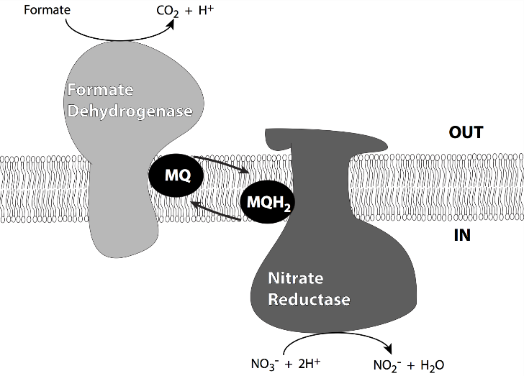
11. __________________ is a reduced form of __________________.
A. glucose; CO₂
B. CO₂; glucose
C. water; CO₂
D. CO₂; water
E. water; glucose

12. Which of the following represents the path of electron transfer in this system?
A. formate formate dehydrogenase MQ nitrate reductase NO₂⁻
B. formate formate dehydrogenase MQ nitrate reductase NO₃⁻
C. NO₂⁻ nitrate reductase MQH₂ formate dehydrogenase CO₂
D. NO₃⁻ nitrate reductase MQH₂ formate dehydrogenase CO₂
E. CO₂ formate dehydrogenase MQ nitrate reductase NO₂⁻
13. The redox table associated with the figure below contains up to two errors. What corrections are necessary to fix the table (choose only one letter)?
- the CO2/Glucose redox couple and the 1/2O₂/H₂O redox couple should switch places (rows in the table)
- the formate dehydrogenase (oxidized form) and (reduced form) should switch columns; the nitrate reductase (oxidized form) and (reduced form) should switch columns
- the NO₃⁻/NO₂⁻ redox couple should be in a row below that of Nitrate reductase
- the NO₃⁻/NO₂⁻ redox couple should be in a row below that of Nitrate reductase; the nitrate reductase (oxidized form) and (reduced form) should switch columns
- the NO₃⁻/NO₂⁻ redox couple should be in a row below that of Nitrate reductase; MQ (reduced form) and MQ (oxidized form) should switch columns

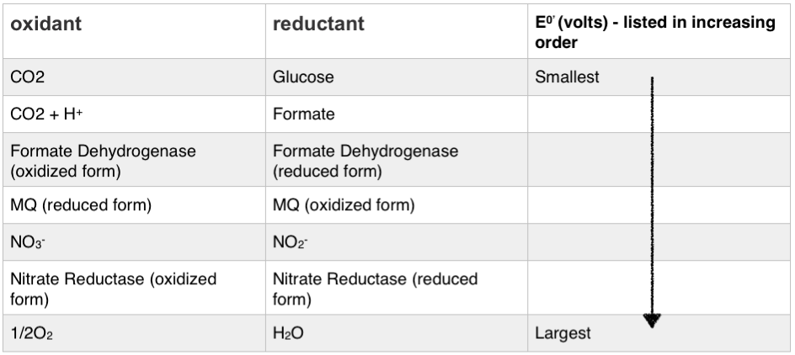

14. The Entoloma hochstetteri mushroom from New Zealand has a beautiful blue coloring. The blue pigment is produced as an end product to a metabolic pathway shown below.
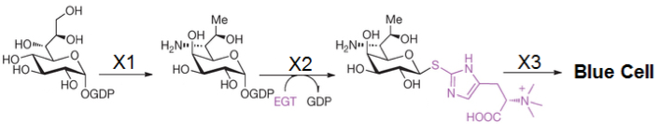
You currently have two haploid mutants of Entoloma hochstetteri, both are white (they are both unable to produce the blue pigment). You mate them to form diploid offspring. You find that the diploid offspring is blue! Which image below most accurately portrays what may have happened?
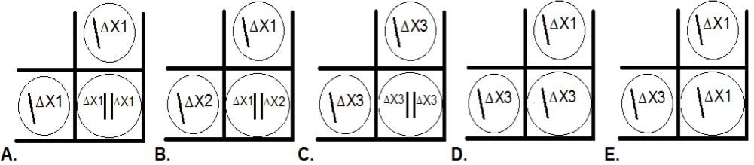

- Embed the key assessment questions in your midterms or other exams. This can be done if you have confidence that the exams align well with the course learning goals e.g., which specific question(s) meet the learning goals? The questions may focus on details when your learning goal is broader so this takes some thought. However, if there were questions with a range of student scores that demonstrate different degrees of proficiency (not just a binary outcome), using an exam question could work.

For example, one course used a multi-part fill-in question to assess student understanding of natural selection. Students had to describe the key components of natural selection and analyze the results of a selection experiment described in the test question. The distributions of student outcomes for several different iterations of these question type are shown below: In outcome A, most students in the class received the majority of the points, at least 10/12. In outcome B, the mean score on the question might look acceptable, but the distribution shows that over half the students correctly completed only half of the question. In outcome C, students had a wide range of skill levels and many were not proficient on this topic. Outcomes B and C suggest that this topic should be taught again; an instructor could show that the students did master the material over the quarter by retesting on this topic on the final examination and showing an improved distribution.

Example: Three score distributions from an assessment on natural selection:

- Give students multiple opportunities to demonstrate the skill over the quarter and provide feedback at each attempt. Record improvement throughout the quarter. This method might be good for demonstrating a skill such as presentation of scientific material: students could give 3 talks over a quarter where the distribution of scores for each talk showed more students with greater proficiency.

- Design a capstone exercise where students create a project requiring a set of skills taught over the quarter or integrating material from previous courses. The project could result in a paper or a portfolio which is then assessed, but there are immediate problems with large classes since someone would have to assess the portfolios. If a group had a capstone exercise already in place, for example a mandatory research component of a major, then faculty could be asked to score students in several categories of research proficiency and the major would have a data distribution for this topic.
There are many other ways learning outcomes could be assessed and faculty are encouraged to develop something appropriate for their material. The scores of the entire class could be monitored as shown in example b, or the class skills could be assessed by sampling, as would occur if a randomly-selected subset of the class were scored. Faculty would have to decide if the fraction of the sample that met the desired standard was adequate.

However, please recognize that a listing of final grades for the course is not
sufficient--your goal is to assess actual student mastery of a certain learning goal (on an absolute scale), not your opinion of their performance relative to other students.

Step 6: Be able to describe your analysis and present sample student work for Program Review and for WASC accreditation.

Student performance data should be archived for each learning goal; faculty may assess the same goal in multiple years if teaching methods were changed to improve outcomes, but the ultimate goals is to know whether students are meeting all the learning goals for the course through sustained assessment over several years.

All individual outcomes of student work do not need to be archived, but there should be examples of student work at each level. For example, in the case of written explanations for the natural selection questions discussed above, one could categories the scores into bins (below standard, meets minimal standard, good performance, exceptional performance) and then keep scans of 5 representatives from each bin for discussion. In a class of 700 students one would have between 20 scans of student work (without identifying data or student names) stored electronically each year, along with data on the proportion of the class whose work was placed in each bin annually.

Each course should create an annual report on the learning goals assessed, methods of assessment, and faculty response to the assessment outcomes. Faculty response would include notes on whether faculty were satisfied with student skill levels for each learning goal, and if not, how the instructor planned to improve outcomes through changes in the course or the curriculum.

Direct assessment of the program learning goals for each major is now required for program review. Assessment within each course will be critical because this is the material likely to combined to show student success; this material could be augmented by student performance in a capstone seminar showing how learning across the curriculum was integrated.

There are many ways the integration and alignment of learning goals can be recorded; if you are interested, see the curriculum map example included with the emailed packet.

Step 7: If your course has General Education (GE) certification, you will need to assess student learning outcomes for this area and include the assessment with Program Review documents. See the Program Review documents for a discussion of GE assessment—a snapshot has been provided below:

